eDocs:

**Dashboard**:

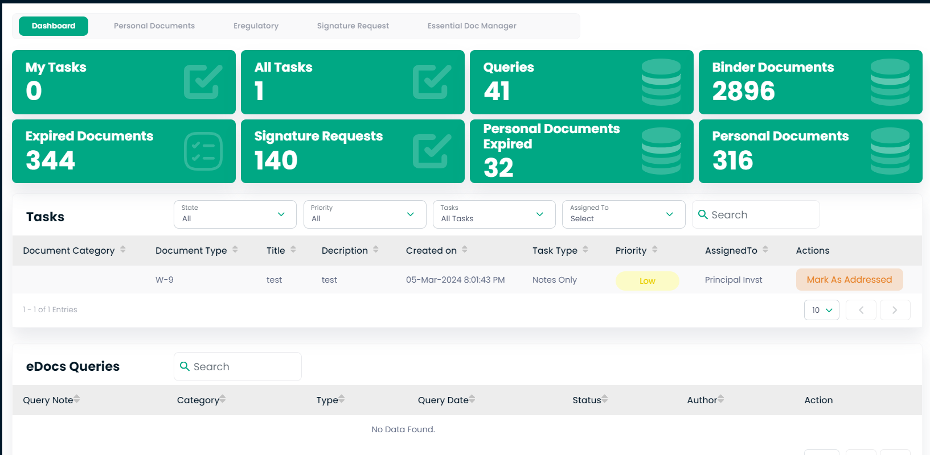

**Overview of Dashboard**

**Step 95: Understanding Dashboard Indicators**

1. The dashboard displays different sections for quick status checks on tasks and documents:
   * My Tasks: Shows the number of tasks assigned to you that need action.
   * All Tasks: Indicates the total number of tasks in the system.
   * Expired Documents: Lists documents that are past their effective date.
   * Signature Requests: Displays pending requests for document signatures.
   * Queries: Indicates the number of queries or outstanding questions.
   * Binder Documents: Shows the total number of documents in binders.
   * Personal Documents: Lists personal documents that are stored in the system.
   * Personal Documents Expired: Shows personal documents that have expired.

**Managing Tasks and Documents**

**Step 96: Handling Tasks**

1. Below the main indicators, you have a "Tasks" list showing individual items that require attention.
2. You can sort and filter tasks by state, priority, and assignment to manage your workload effectively.

**Step 97: Addressing eDocs Queries**

1. The "eDocs Queries" section is for managing queries related to electronic documents.
2. You can search for specific queries using the search bar and filter them by category, type, date, and status.

**Utilizing Actions**

**Step 98: Taking Action on Items**

1. Actions can be taken directly from the dashboard, such as marking tasks as completed or addressing queries.
2. Use the “Mark As Addressed” or similar buttons to update the status of tasks and queries as you work through them.

![Insert Screenshot 51 Here: The document management dashboard with various sections and indicators.]

Personal Document:

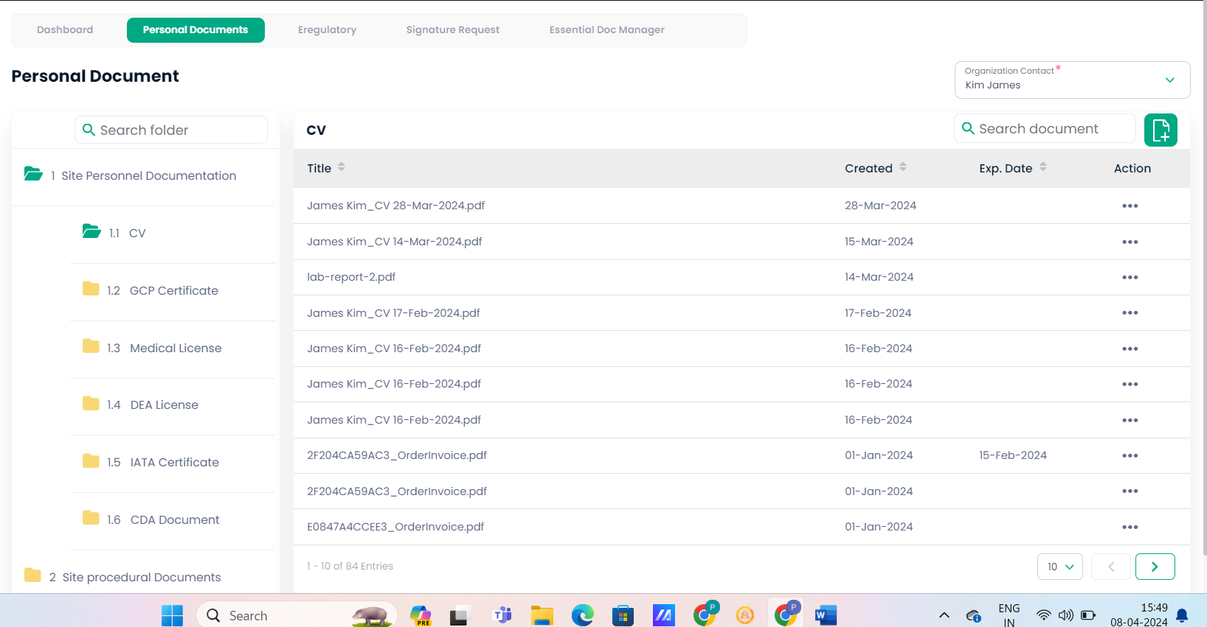

**Accessing Personal Documents**

**Step 99: Viewing Personal Documents**

1. To view and manage personal documents such as CVs, certificates, and licenses, click on the "Personal Documents" tab from the main dashboard.
2. You'll see a sidebar categorizing documents for easy navigation.

**Navigating Document Categories**

**Step 100: Exploring Categories and Documents**

1. The sidebar lists categories like CV, GCP Certificate, Medical License, etc. Click on a category to filter and display only the relevant documents in the main panel.
2. Within the "CV" section, for instance, you’ll find a list of all CV documents uploaded for the individual or role selected in the "Organization Contact" dropdown menu.

**Document List and Actions**

**Step 101: Interacting with the Document List**

1. The main panel shows the document title, the date created, and the expiration date if applicable.
2. You can take various actions on each document by clicking the three dots or "action" button next to it – options may include view, download, delete, or update information.

**Step 102: Adding or Updating Documents**

1. To add a new document or update an existing one, you might use an "Add" button or similar function within the category or document list.
2. Follow prompts to upload new documents, input relevant details, and save them to your profile.

**Step 103: Using Search Functions**

1. Utilize the search bars to quickly find documents within a folder or the entire personal document section.
2. This is particularly useful when managing a large number of documents or when looking for a specific file.

![Insert Screenshot 52 Here: The personal documents interface showing the document categories and the list of CVs.]

Add Document:

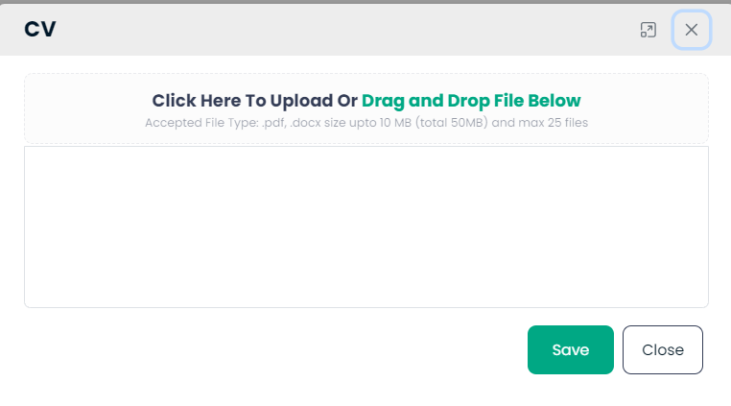\

**Uploading Documents**

**Step 104: Accessing the Upload Interface**

1. Open the document upload interface by selecting the option to add or update your CV.

**Step 105: Adding Your Document**

1. You can upload your document by either:
   * Clicking on the area that says "Click Here To Upload" and selecting the file from your computer.
   * Dragging and dropping the file into the designated area.

**Note:**

* Ensure the document is in the accepted file format (.pdf, .docx) and does not exceed the specified size limit (up to 10 MB for individual files, with a total limit of 50 MB for multiple files).
* The system may allow a maximum of 25 files to be uploaded simultaneously.

**Step 106: Saving the Uploaded Document**

1. After the file has uploaded, make sure to click the "Save" button to store the document in your profile.
2. If you need to upload additional documents, repeat the process as needed.

**Closing the Interface**

**Step 107: Finalizing the Process**

1. Once you have finished uploading, click the "Close" button to exit the upload interface.

![Insert Screenshot 53 Here: The CV/document upload interface with the drag and drop area.]

E-regulatory:

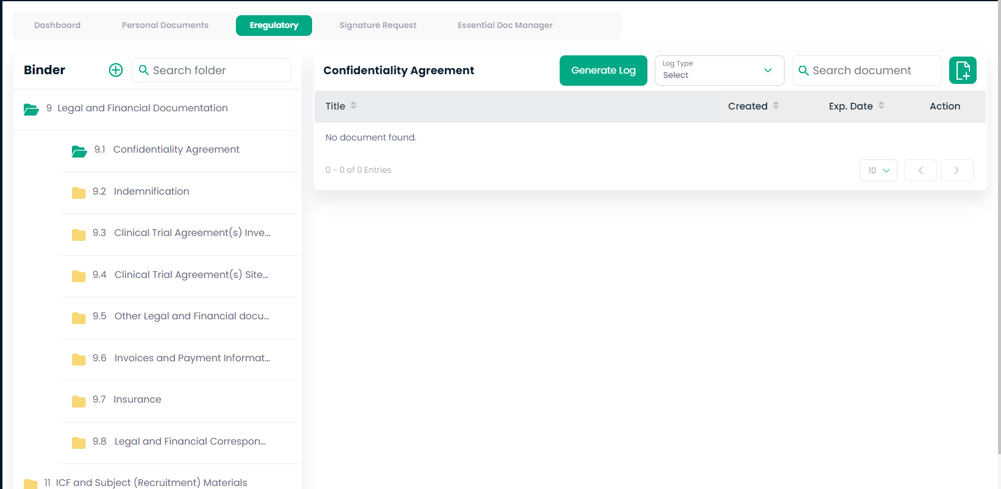

**Accessing the Confidentiality Agreement Section**

**Step 108: Navigating to the Confidentiality Agreements**

1. From the "Binder" tab in the document management system, locate the "Legal and Financial Documentation" section.
2. Expand this section and click on "9.1 Confidentiality Agreement" to view documents related to confidentiality agreements.

**No Documents Found**

**Step 109: Adding Documents**

1. If no documents are found within this section, you can add new documents by using an upload function, typically indicated by a plus icon or an "Add Document" button.

**Managing Document Logs**

**Step 110: Using the Generate Log Function**

1. To keep track of actions or updates made to confidentiality agreements, use the "Generate Log" feature. This will create a record of all entries and changes for auditing purposes.

**Step 111: Searching for Specific Documents**

1. Utilize the search bar labeled "Search document" to quickly find specific confidentiality agreements by title, date, or other metadata.
2. The system may also offer advanced filtering options to narrow down your search results.

**Action and Document Details**

**Step 112: Reviewing and Taking Actions**

1. When documents are present, the interface will display details such as the document title, creation date, expiration date, and available actions.
2. Use the action buttons to view, edit, renew, or delete documents as needed. This will ensure that your confidentiality agreements are up-to-date and accessible.

![Insert Screenshot 54 Here: The 'Confidentiality Agreement' section within the binder.]

Add Document:

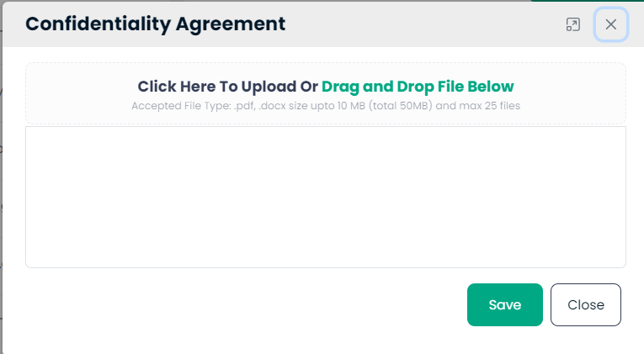

Add New Category:  
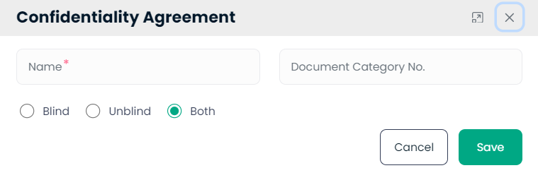

**Step 113: Accessing the Confidentiality Agreement Form**

1. Open the form where you can add a new confidentiality agreement or edit an existing one.

**Step 114: Entering Agreement Details**

1. In the "Name" field, enter the full name of the individual or entity that the agreement is with.
2. If applicable, enter the "Document Category No." to classify the agreement within your organization’s documentation system.

**Step 115: Selecting the Type of Agreement**

1. Choose the appropriate confidentiality level by selecting one of the following:
   * Blind: Information will be concealed from certain parties.
   * Unblind: Information will be fully accessible.
   * Both: Applies to situations where the document may be both blind and unblind, depending on context or parties involved.

**Step 116: Saving the Agreement**

1. Review the information you've entered to ensure accuracy.
2. Click "Save" to store the confidentiality agreement within the system.

**Step 117: Canceling or Closing**

1. If you decide not to save the information, click "Cancel" to exit without saving changes.
2. To close the form, click the "X" button on the top right.

![Insert Screenshot 55 Here: The 'Confidentiality Agreement' form.]

Signature Request:

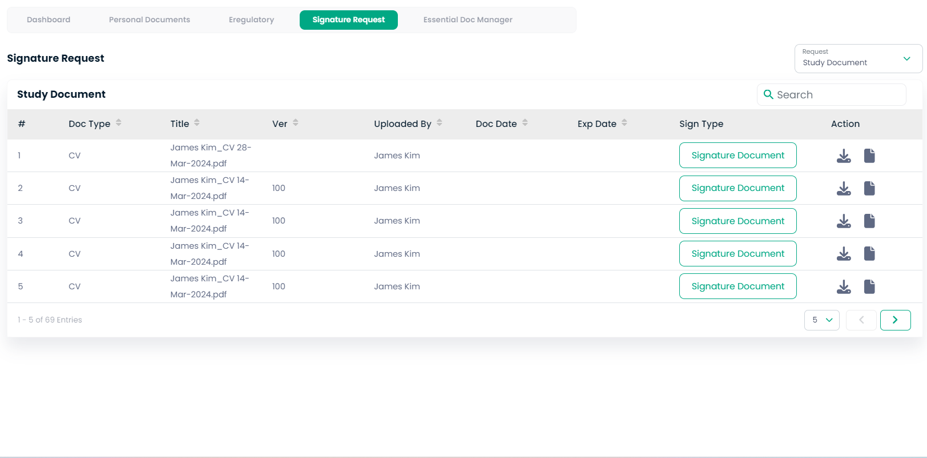

**Overview of the Signature Request Interface**

**Step 118: Viewing Pending Signature Requests**

1. In the "Signature Request" tab, you have a list of documents pending signatures. This section may be used to manage and track signature processes for study documents.

**Understanding Document Details**

**Step 119: Reviewing Document List**

1. The table displays multiple columns for detailed document management:
   * Doc Type: Type of document awaiting a signature.
   * Title: Name of the document, which may include the date or version number for identification.
   * Ver (Version): The version number of the document if multiple iterations exist.
   * Uploaded By: The individual who uploaded the document.
   * Doc Date: The date the document was created or uploaded.
   * Exp Date: The expiration date of the document, if applicable.
   * Sign Type: Indicates the method of signing required (e.g., electronic, manual).

**Taking Action**

**Step 120: Initiating Signatures**

1. To start the signature process, click on the "Signature Document" button corresponding to the document that requires a signature.

**Step 121: Signature Workflow**

1. Follow the prompts to sign the document or send it to the appropriate party for signing.

**Step 122: Managing Requests**

1. The action column also provides options to view, download, or delete the signature request.
2. Use the search bar to quickly find specific documents by title or other details.

**Step 123: Pagination and Navigation**

1. Use the pagination options at the bottom to navigate through multiple entries if there are more documents than can be displayed on a single page.

![Insert Screenshot 56 Here: The 'Signature Request' section with the list of documents pending signatures.]

Signature Document:

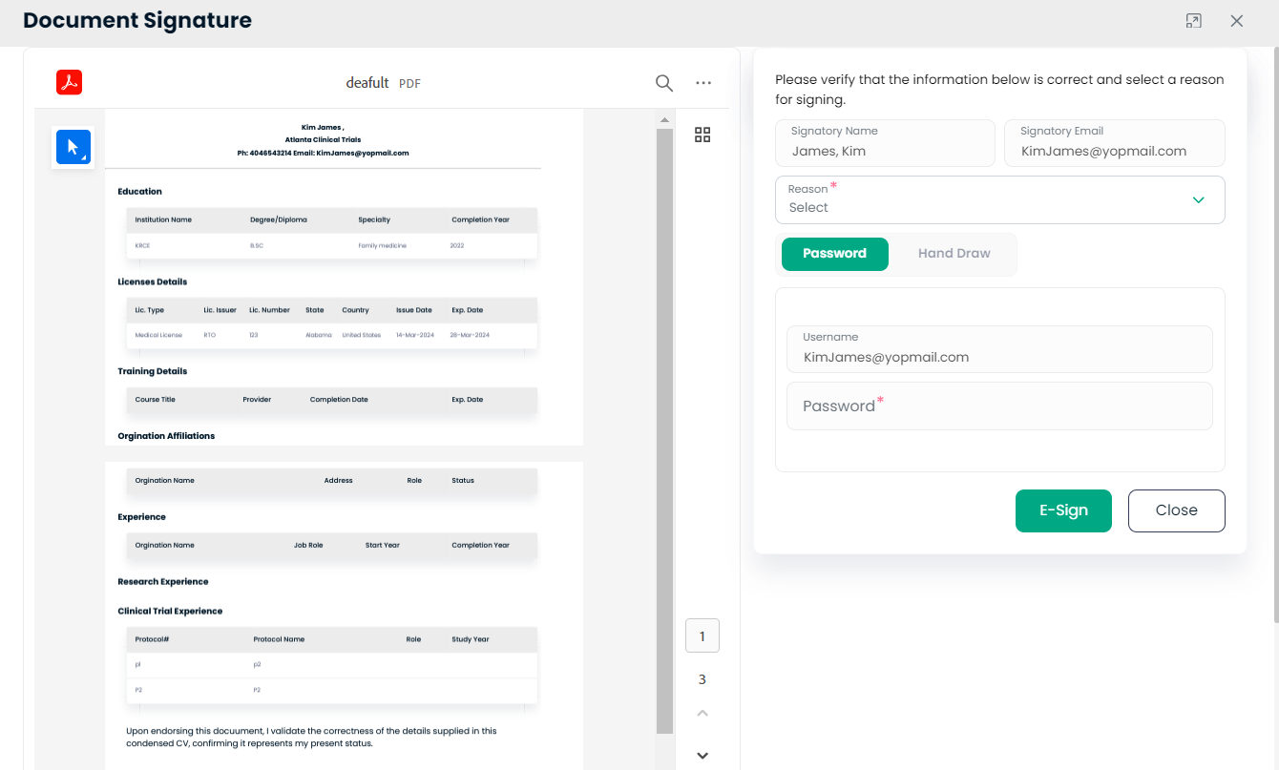

**Reviewing the Document for Signature**

**Step 124: Examining the Document**

1. Before signing, review the displayed document to verify that all personal details, educational background, license details, affiliations, and experiences are correct.

**Signature Verification Panel**

**Step 125: Verifying Signatory Information**

1. On the right-hand side, confirm the signatory's name and email address. These should pre-populate based on user profile information.

**Selecting the Reason for Signing**

**Step 126: Indicating the Reason for Signing**

1. Choose a reason for signing from the dropdown menu labeled "Reason*." This may be required to contextualize the signature within the document’s lifecycle.

**Authentication for E-Signature**

**Step 127: Authenticating Signatory Identity**

1. Select the method of signature authentication—either by inputting a password or using a hand-drawn signature.
2. If using a password, enter it in the "Password*" field to validate the signature.

**Finalizing the Signature**

**Step 128: Completing the E-Signature**

1. After ensuring that all information is accurate and the authentication is set, click the "E-Sign" button to apply your signature to the document.

**Step 129: Closing the Signature Interface**

1. If you need to exit without signing, click the "Close" button. This will cancel the signing process and close the panel.

![Insert Screenshot 57 Here: The 'Document Signature' interface with the document on the left and the signature verification panel on the right.]

Essential Doc Manager:

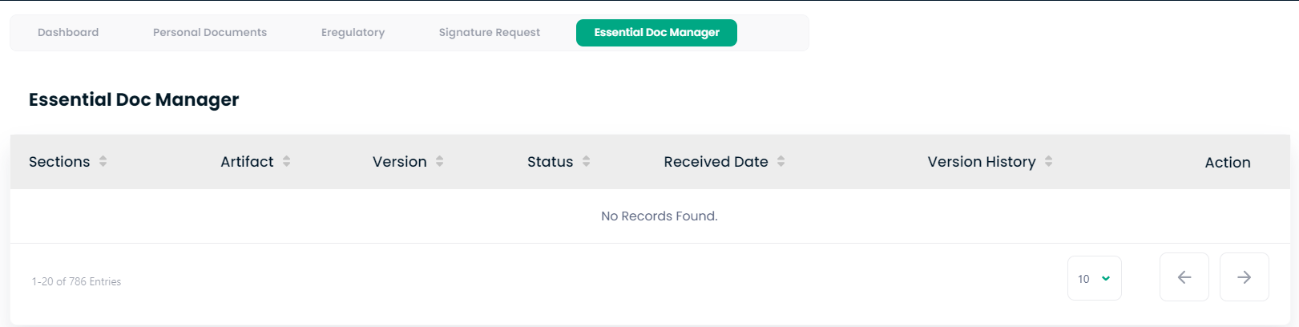

**Step 130: Introduction to the Essential Doc Manager**

1. The "Essential Doc Manager" is where critical study documents are managed. When you're in this tab, you'll see a list of documents categorized by section, type, version, and status.

**No Records Found**

**Step 131: When No Documents Are Present**

1. If "No Records Found" is displayed, this means there are no documents currently uploaded or associated within this particular section.

**Document Management Functions**

**Step 132: Uploading Documents**

1. To add documents to the Essential Doc Manager, look for an upload button, often represented by a plus icon or labeled "Upload" or "Add New".

**Step 133: Searching and Filtering Documents**

1. Utilize search and filter functionalities to locate specific documents or to check what documents are due for an update or review.

**Pagination and Navigation**

**Step 134: Reviewing Multiple Entries**

1. Use the pagination controls at the bottom of the page to navigate through the list of entries if your system has many documents.

**Taking Action**

**Step 135: Taking Action on Documents**

1. When documents are available, you will have various actions to take, such as view, edit, download, or update document statuses. These will be represented by icons or buttons in the "Action" column.

![Insert Screenshot 58 Here: The 'Essential Doc Manager' interface with options for document management.]

**Source-eBuilder**:

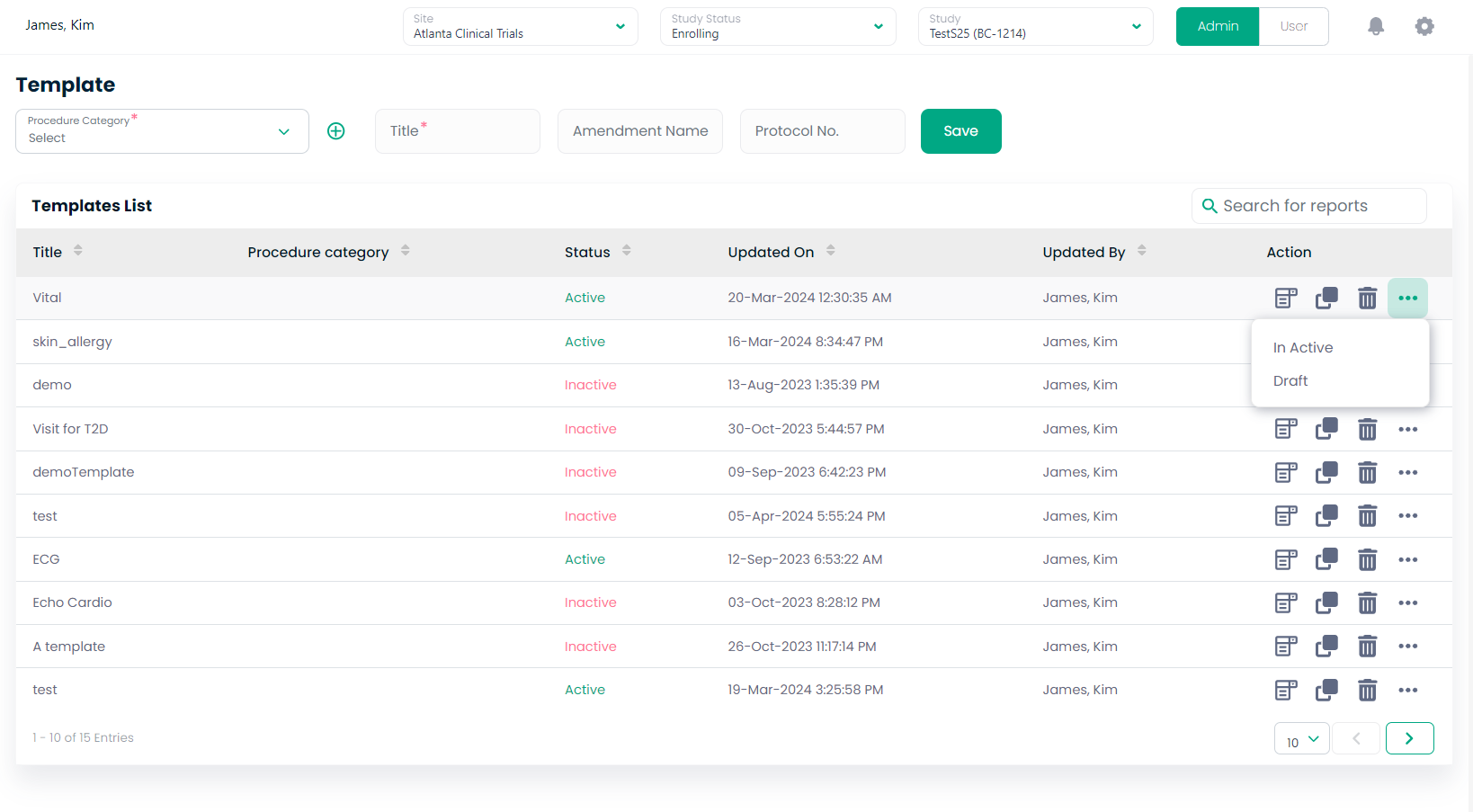

**Overview of the Template Management Interface**

**Step 136: Understanding the Template Dashboard**

1. This screen is your dashboard for managing procedural templates. You'll see a list that includes titles, categories, statuses, and other key details for each template.

**Creating and Saving Templates**

**Step 137: Adding New Templates**

1. To create a new template, you would typically fill out the fields at the top, such as 'Procedure Category', 'Title', 'Amendment Name', and 'Protocol No.'
2. Once the necessary information is entered, you would click "Save" to add the template to your list.

**Managing Existing Templates**

**Step 138: Editing or Viewing Templates**

1. In the 'Templates List', you can take various actions like editing or viewing details by clicking on the corresponding icons under the 'Action' column.
2. You can also filter the list by status—'Active' or 'Inactive'—to streamline your view.

**Navigating the List**

**Step 139: Searching and Sorting Entries**

1. Use the search bar to quickly find specific templates.
2. Sort your list by clicking on any column header like 'Title', 'Updated On', or 'Status' to reorder the list based on that criterion.

**Template Status and Version Control**

**Step 140: Updating Template Status**

1. Toggle the status of templates directly from the list to mark them as 'Active' or switch to 'Draft' or 'Inactive', as needed.

**Pagination**

**Step 141: Navigating Through Pages**

1. If your template list is extensive, use the pagination controls at the bottom to view more entries.

![Insert Screenshot 61 Here: Template management interface showing a list of procedural document templates.]

**Add Procedure category**:

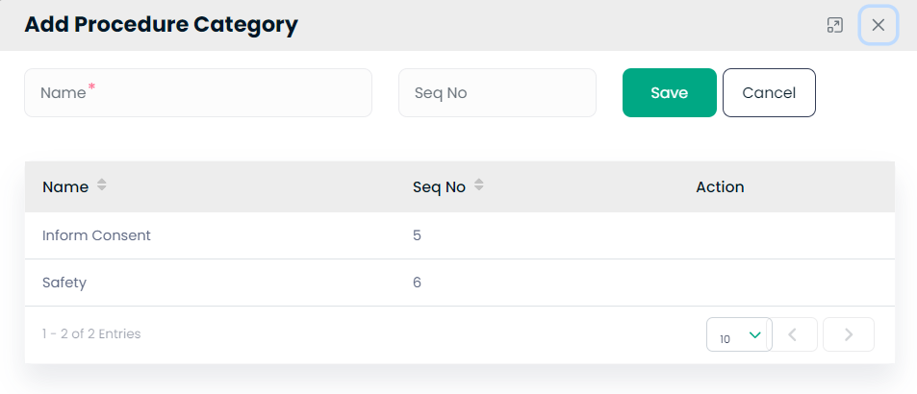

**Adding Procedure Categories**

**Step 142: Procedure Category Creation**

1. On the "Add Procedure Category" screen, you will see a form to input the name of a new procedure category.
2. Enter the desired name of the category in the 'Name' field.
3. Assign a 'Seq No' which may be used to order the category in listings.
4. Click "Save" to store the new category or "Cancel" to discard the entry.

**Step 143: Reviewing Procedure Categories**

1. Below the input form, the list displays existing categories.
2. Each entry includes the category name, its sequence number, and actions like edit or delete, which can be performed using the buttons in the 'Action' column.

![Insert Screenshot 63 Here: Interface for adding and listing procedure categories.]

**Creating Forms**

**Step 144: Form Builder Overview**

1. The form builder screen provides various 'Filter Elements' that can be added to a form, such as Textboxes, Checkboxes, Radio Buttons, and more.
2. To add an element to your form, click on the corresponding 'Add' button. This will add the element to the 'Form Fields' section.

**Step 145: Customizing Form Fields**

1. In the 'Form Fields' area, you can see the layout of your form.
2. Here you can enter questions or information that will be presented to the user. You can customize elements like 'Date of birth' or signature fields.
3. Use the icons to rearrange or delete fields.

**Step 146: Saving the Form**

1. Once you are satisfied with the form, click "Save" to preserve your design or "Preview" to see how the form will look when in use.
2. To add more pages to the form, click "Add Page."

![Insert Screenshot 64 Here: Interface for adding and arranging form elements.]

**Build Template**:

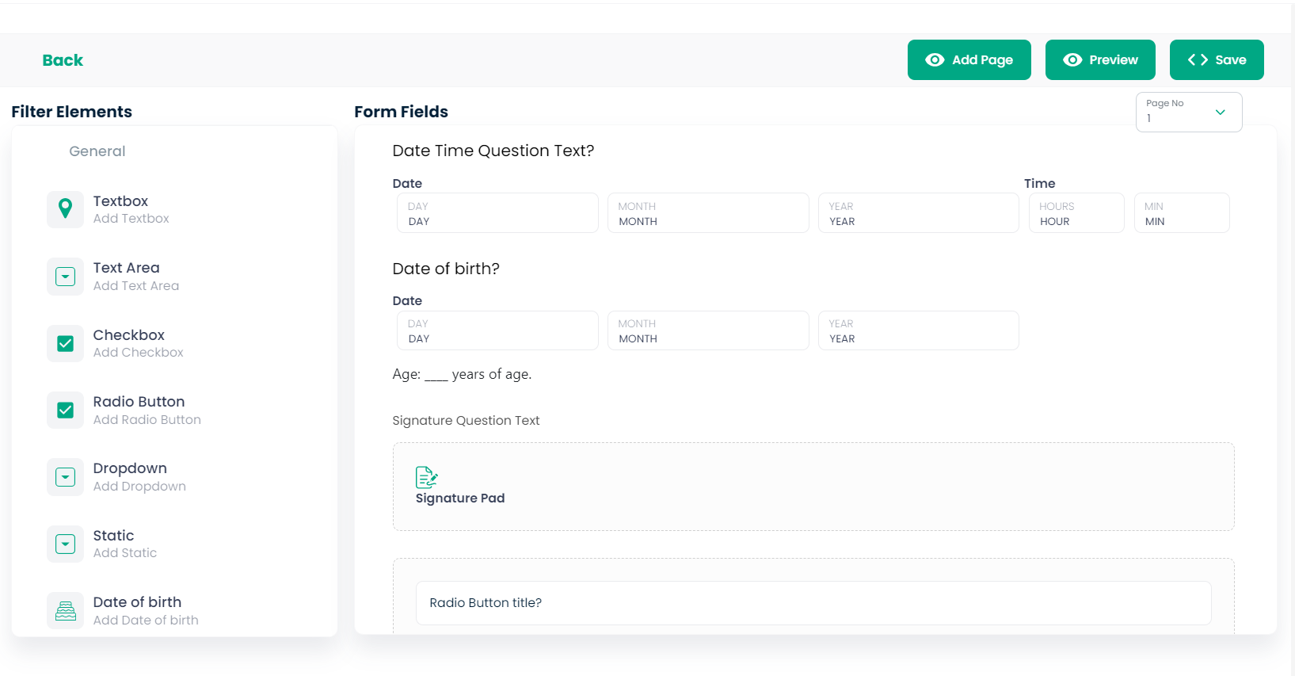

e-Consent:

Admin:

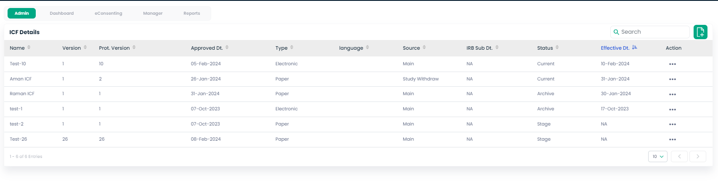

Add E-consent Manage:  
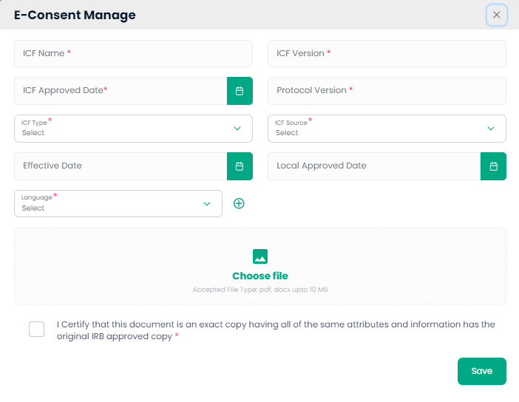  
Preview Consent:

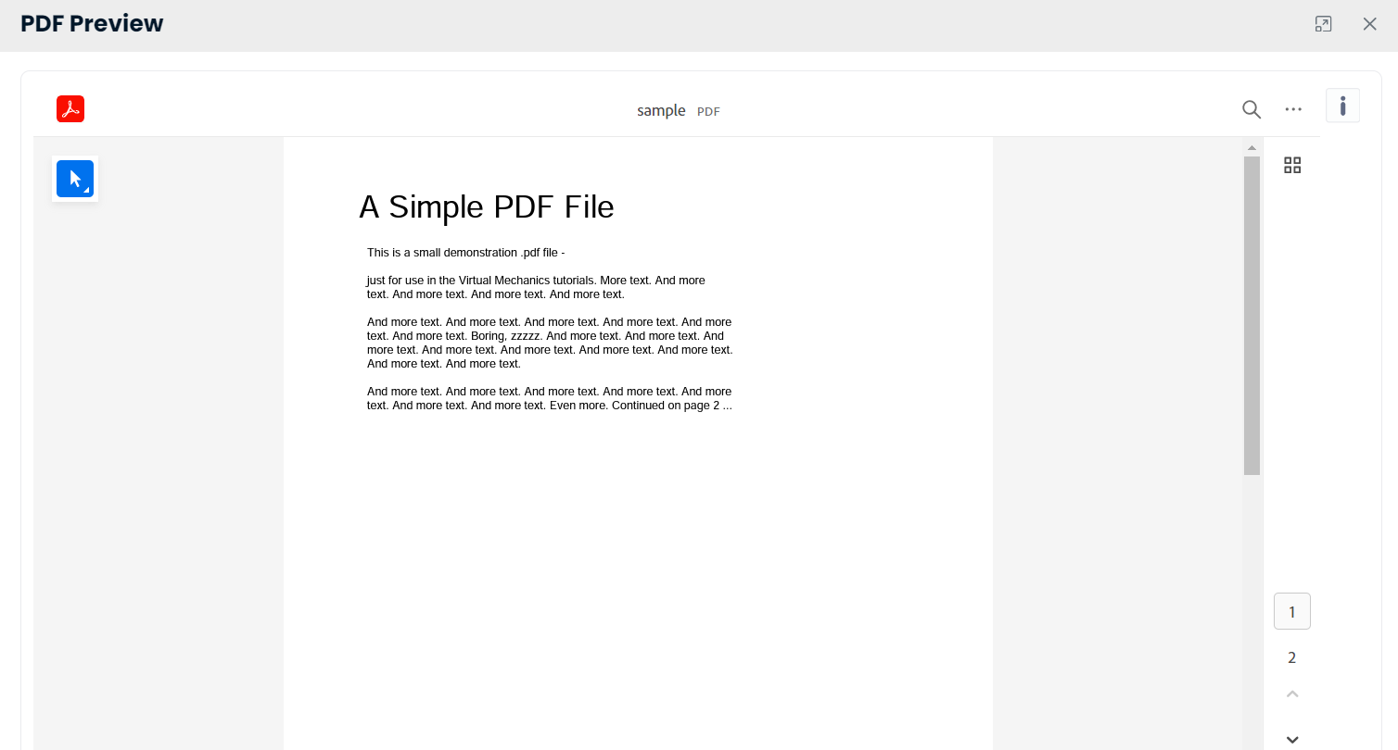Update ICF Status:  
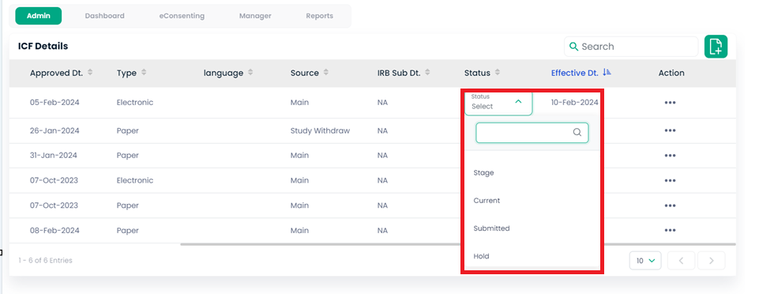Update Effective Date:

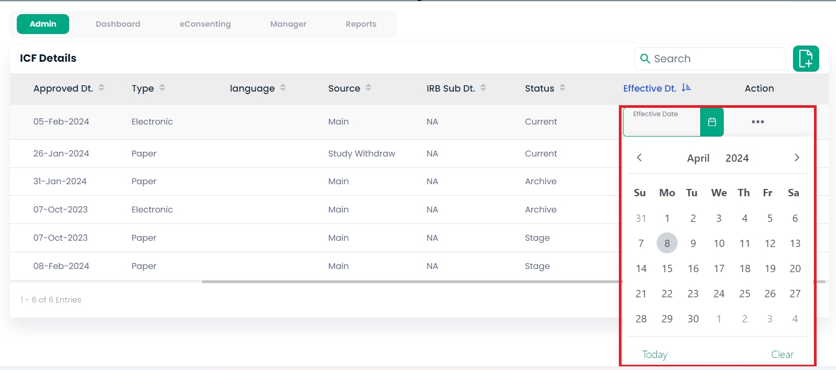

**Managing ICF Details**

**Step 147: Overview of ICF Management**

1. In the 'ICF Details' view, you’ll see a list of ICF documents with information such as Name, Version, Approved Date, Type, Language, Source, IRB Sub Date, Status, Effective Date, and Actions available.

**Step 148: Updating ICF Details**

1. To update an ICF, locate the desired entry in the list.
2. Click on the '...' under the Action column to edit details, view history, or delete the ICF.
3. To filter the list, use the 'Search' bar or the sorting features in each column header.

![Insert Screenshot 67 Here: Interface showing ICF Details]

**Using e-Consent Management**

**Step 149: Adding a New e-Consent Document**

1. To add a new e-Consent document, click on the 'E-Consent Manage' button.
2. Fill in the required fields such as ICF Name, ICF Version, ICF Approved Date, and Protocol Version.
3. Choose the ICF Type and Source, set the Effective Date, and select the Language.
4. Use the 'Choose file' button to upload the document file.
5. Confirm the information by ticking the certification checkbox, then click 'Save'.

**Step 150: Reviewing PDF Previews**

1. For a quick review, click on the PDF Preview to open a full-screen view of the ICF document.
2. Navigate through the document using the preview controls.
3. Close the preview to return to the ICF list.

**Step 151: Changing ICF Status**

1. To change the status of an ICF, click on the status dropdown for the specific entry.
2. Select the new status from options such as Current, Submitted, Hold, etc.
3. Save changes if necessary or use the calendar icon to adjust the Effective Date.

![Insert Screenshot 68, 69, and 70 Here: Interfaces for e-Consent management, PDF preview, and changing ICF status.]

Audit History:

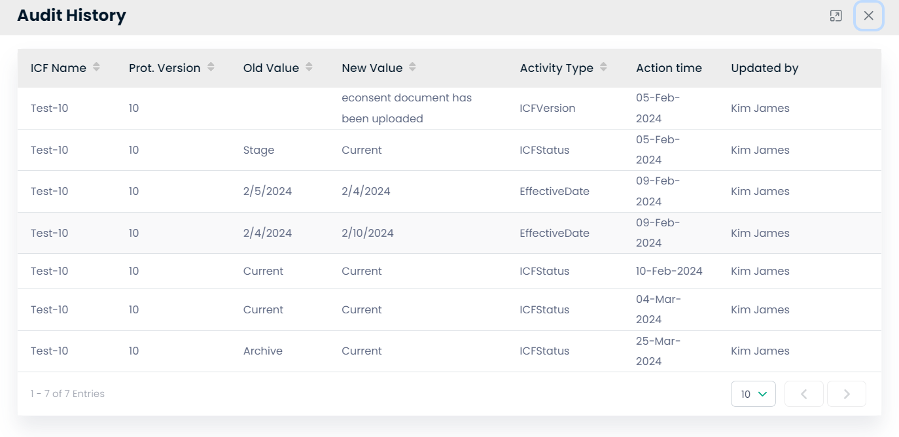

**Step 152: Accessing Audit History**

1. To review the changes made to ICF documents, navigate to the 'Audit History' section.
2. Here, you will find a detailed log of all the modifications, showing the ICF Name, Protocol Version, changes made, along with who made the change and when.

**Step 153: Understanding Audit Entries**

1. The 'Old Value' and 'New Value' columns display what was changed, such as status updates or new document uploads.
2. 'Activity Type' indicates the kind of change that was made, such as updating the ICF version or status.
3. 'Action Time' and 'Updated by' provide a timestamp and the individual responsible for the update.

**Step 154: Navigating the Audit History**

1. To navigate through the entries, use the page navigation controls at the bottom of the list.
2. For a larger overview, adjust the number of entries shown by selecting a different number from the dropdown menu next to the navigation controls.

![Insert Screenshot 71 Here: Interface showing the Audit History for ICFs]

**Using this audit trail, you can ensure accountability and transparency in document management processes, providing crucial oversight for clinical trial operations.**

Prepare eSign Document:

**Step 155: Accessing eSign Templates**

1. Open the eSign Templates module to create or modify digital signature templates.
2. This interface is used to standardize electronic signatures across different documents and processes.

**Step 156: Creating a New eSign Template**

1. Choose the type of eSign template from the dropdown menu labeled 'eSign Template Type'.
2. Provide a description for the template in the 'Description' field to clarify its use or content.

**Step 157: Reviewing Existing Templates**

1. Scroll down to view the 'Templates List', which outlines all available eSign templates.
2. Here you can see the type of signature required (e.g., Two-Way Signature, Three-Way Signature) and their descriptions.

**Step 158: Modifying Templates**

1. To edit a template, click the pencil icon under the 'Action' column.
2. To delete a template, click the trash bin icon. Ensure you only delete templates that are no longer in use or necessary.

**Step 159: Saving Template Changes**

1. After making changes or creating a new template, click the 'Save' button to apply these changes.

![Insert Screenshot 73 Here: Interface for eSign Templates with options to create and manage templates]

**This section is crucial for maintaining the integrity and uniformity of electronic signatures, a key aspect of document verification and approval in clinical studies.**

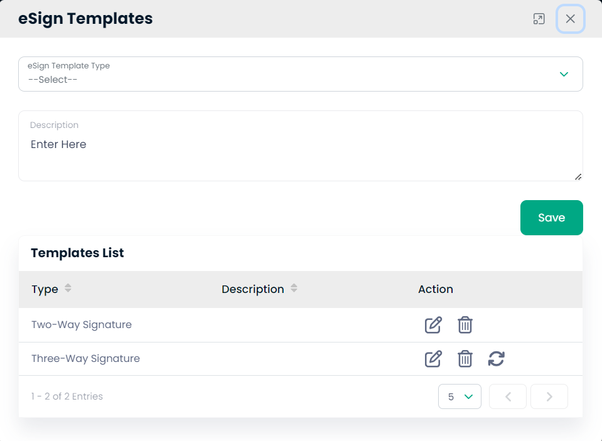

Dashboard:

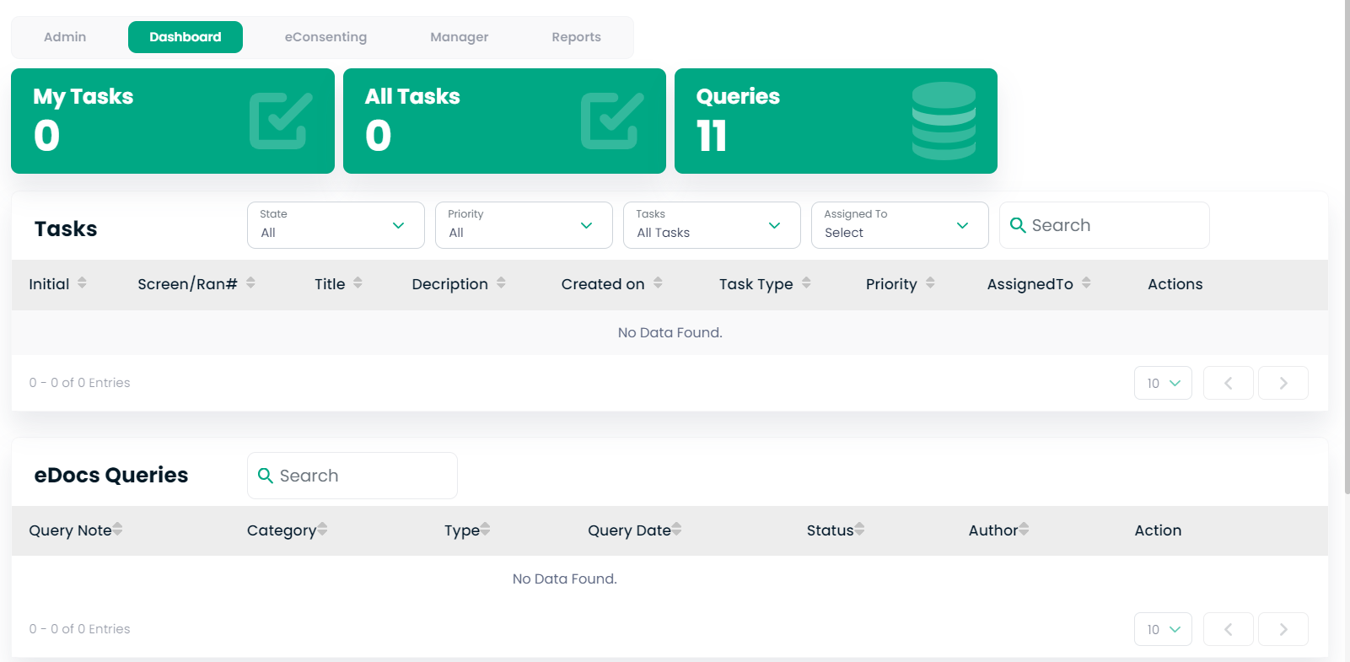

**User Guide: Navigating the Dashboard in Clinical Trial Management System**

**Step 1: Understanding the Dashboard Overview**

1. Log into the clinical trial management system to view the Dashboard.
2. The Dashboard provides a quick overview of tasks and queries that require your attention.

**Step 2: Task Management**

1. The 'My Tasks' and 'All Tasks' sections will show tasks assigned to you and all available tasks, respectively.
2. If you have tasks assigned, they will be listed under the 'Tasks' section.

**Step 3: Query Management**

1. The 'Queries' section keeps track of all outstanding queries.
2. If there are queries listed, you can manage them by selecting the corresponding action from the 'Actions' column.

**Step 4: No Tasks or Queries Found**

1. If 'No Data Found' is displayed under tasks or queries, it means there are no pending items in these categories.

**Step 5: Searching and Filtering**

1. Use the search bars to filter tasks and queries based on specific criteria.
2. Utilize dropdown menus to filter by 'State', 'Priority', 'Tasks', and 'Assigned To' for a more refined view.

![Insert Screenshot Here: Dashboard showing task and query management sections]

**Note:** The dashboard is your central hub for tracking and managing day-to-day activities related to the clinical study. Regularly check for updates and pending items.

eConsenting:

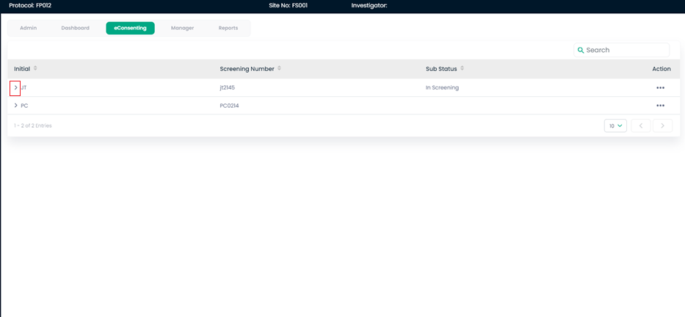

**Managing Consent Screening in Clinical Trial Management System**

**Step 1: Accessing Consent Screening**

1. From the main dashboard, select the 'eConsenting' module to manage informed consent forms related to study subjects.
2. This screen displays subjects’ initials and screening numbers, and their current sub-status in the screening process.

**Step 2: Reviewing Subject Consent Details**

1. To see detailed information about the subject's consent, click on the action button (three dots) next to the subject’s initials.
2. A detailed view will open, showing the subject's name, contact details, and gender. This ensures you have all the necessary information to manage their consent status.

![Insert Screenshot Here: Detailed view of subject consent information]

**Step 3: Updating Consent Status**

1. Update the sub-status of the subject’s consent as needed by selecting the appropriate option from the action menu. This could include changing status to 'In Screening', 'Consented', or other relevant stages.
2. Make sure to document any changes or notes regarding the subject's screening and consent status in the system for audit trails and compliance.

**Note:** Keeping accurate records in the eConsenting module is essential for compliance with regulatory requirements and for maintaining the integrity of the clinical trial process.

Subject Details:

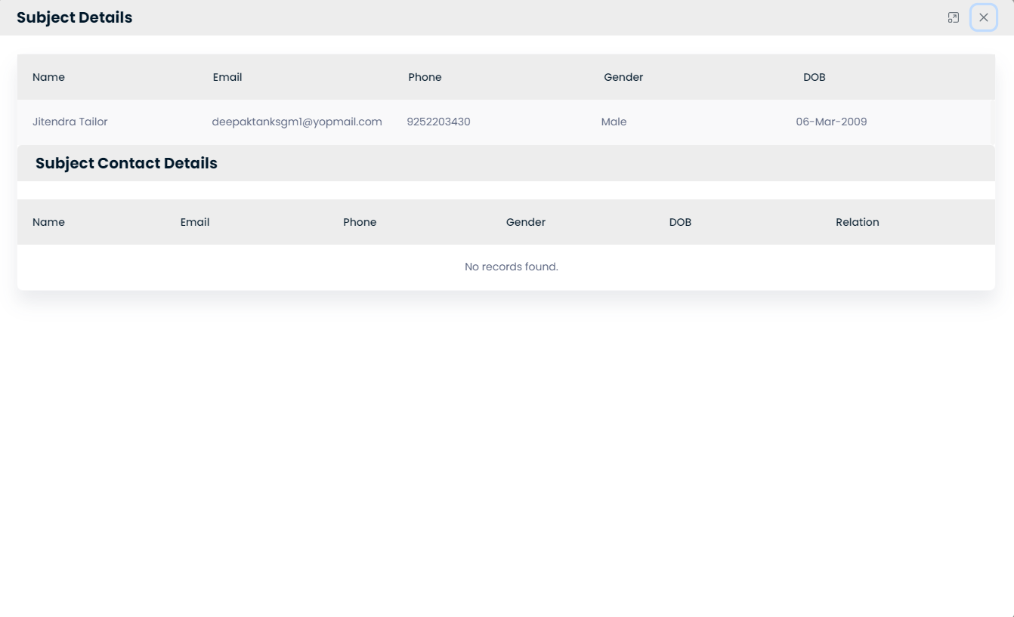

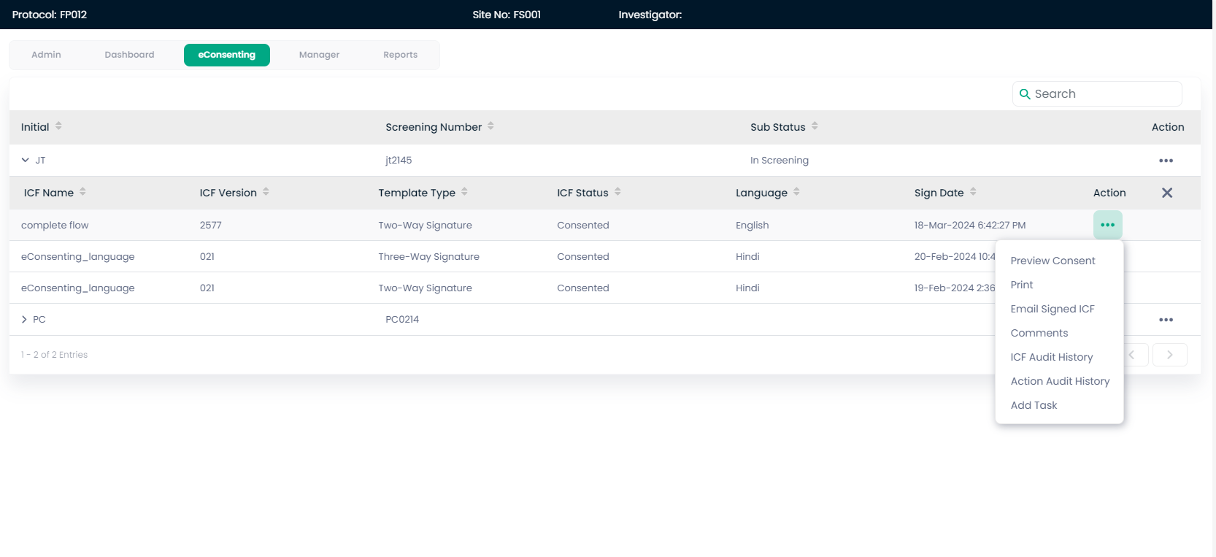

**Managing Informed Consent Forms in Clinical Trial Management System**

**Step 1: Navigating to eConsenting Dashboard**

1. From the administrative dashboard, select the ‘eConsenting’ tab to manage electronic informed consent forms (ICFs).
2. This area displays a list of subjects with their initials, screening numbers, and detailed ICF information.

**Step 2: Managing ICF Information**

1. To view or manage the ICFs for a subject, use the action buttons in the 'Action' column corresponding to a subject's entry. These actions may include viewing the consent form, auditing changes, or adding tasks related to the subject’s consent.

**Step 3: Reviewing and Signing ICFs**

1. To review an ICF, click the 'Preview Consent' option to open and read the document.
2. For subjects who have consented, the 'Sign Date' indicates when the ICF was signed. You can click on 'Email Signed ICF' to send the document to required parties or access 'ICF Audit History' for a log of all activities related to the ICF.

**Step 4: Auditing Consent Forms**

1. To maintain proper records and ensure compliance, use the 'ICF Audit History' to view a detailed log of all actions taken with respect to each ICF, such as updates to the status, version changes, or amendments.

![Insert Screenshot Here: ICF Audit History view]

**Note:** Consistent monitoring and management of ICFs are crucial for ethical standards and regulatory compliance in clinical trials. Ensure all changes and actions are recorded accurately for future reference.

Preview Consent:

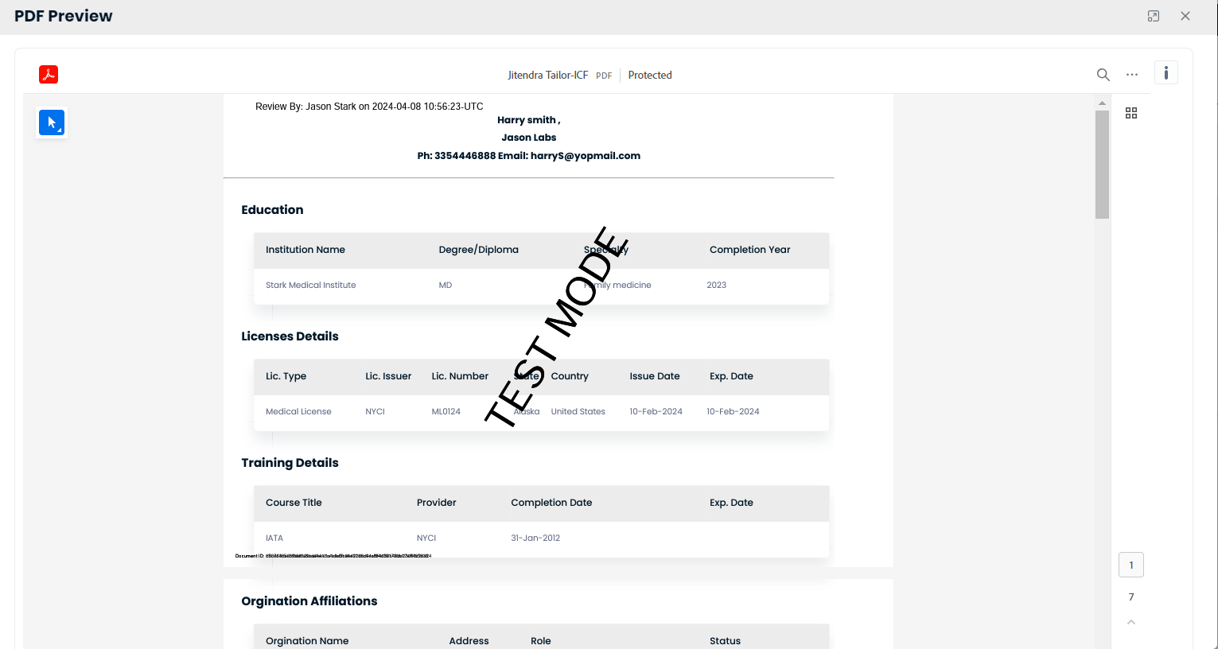

### ****Reviewing and Sharing Documents in Clinical Trial Management System****

**Step 1: Document Review**

1. Navigate to the 'Personal Documents' section of the dashboard.
2. To preview a specific document, such as a CV or certification, click the document's link in the list.
3. Review the details in the PDF preview pane to ensure accuracy before sharing.

![Insert Screenshot Here: PDF Preview Pane]

**Step 2: Printing Documents**

1. If a physical copy is needed, use the print function by clicking on the print icon in the PDF preview pane.
2. Choose the desired printer and settings, then click 'Print' to produce a hard copy.

![Insert Screenshot Here: Printing Interface]

**Step 3: Sharing Documents**

1. To share a signed informed consent form (ICF), navigate to the 'Share Email Signed ICF Document' window.
2. Confirm the action by reviewing the recipient's details and clicking 'Send' to distribute the document via email.

![Insert Screenshot Here: Share Email Signed ICF Document]

**Step 4: Commenting on Documents**

1. To leave comments on a document, select the 'Comments' option from the document's action menu.
2. Type your comment in the provided field and click 'Save' to add it to the document's record.

![Insert Screenshot Here: Comments Interface]

Print:

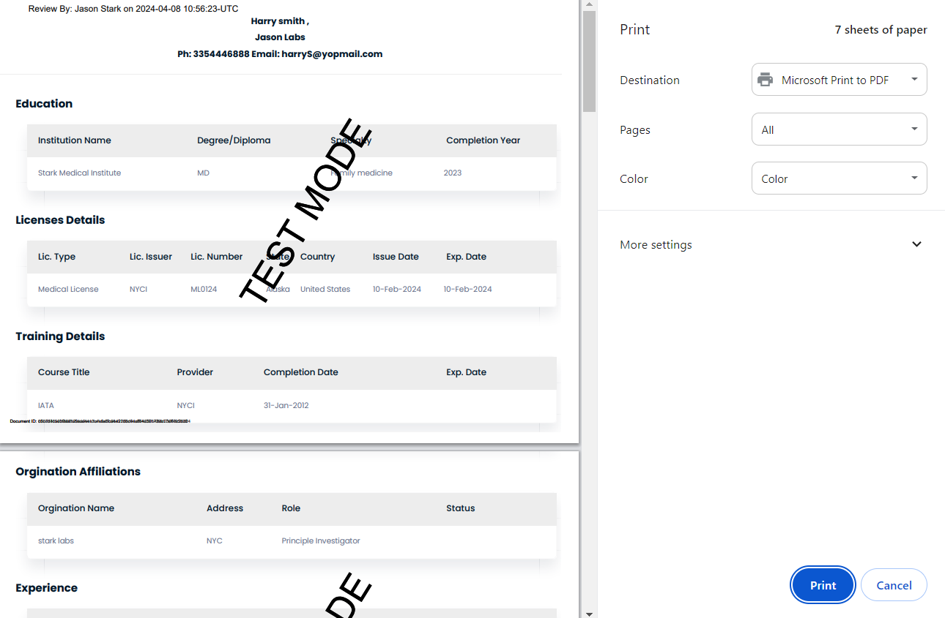

Email Signed ICF:

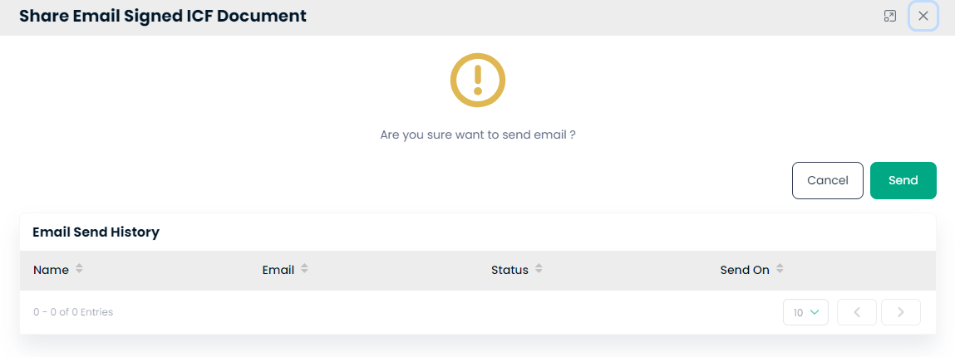

Comments:

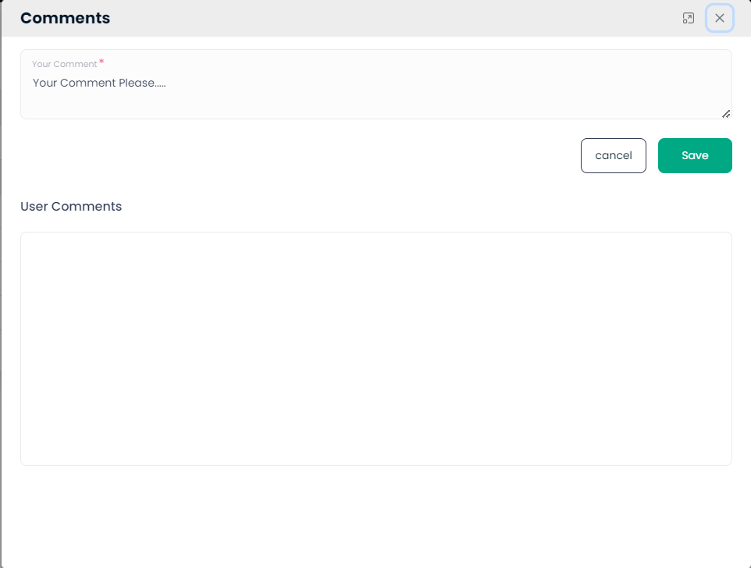

ICF Audit History:  
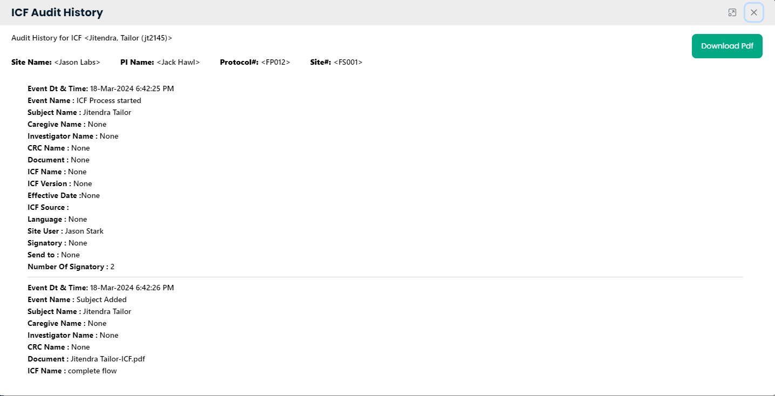

### ****Managing ICF Audit and Action Histories in a Clinical Trial Management System****

**Step 1: Accessing ICF Audit History**

1. From the main dashboard, navigate to the eConsenting section.
2. Select a subject to view their ICF details.
3. Click on the 'Audit History' to review all actions taken regarding the subject's ICF, including the start of the ICF process and document upload.

![Insert Screenshot Here: ICF Audit History Screen]

**Step 2: Reviewing Action Audit History**

1. Within the subject's ICF details, access the 'Action Audit History'.
2. Review the recorded actions, who performed them, and when they were done to ensure compliance and traceability.

![Insert Screenshot Here: Action Audit History Screen]

**Step 3: Adding and Managing Tasks**

1. If you need to assign a task related to the ICF or any action, click the 'Add Task' button.
2. Fill in the required fields, such as task type, priority, assignee, and description.
3. Save the task to assign it and track it in the task history.

![Insert Screenshot Here: Add Task Screen]

Action audit history:  
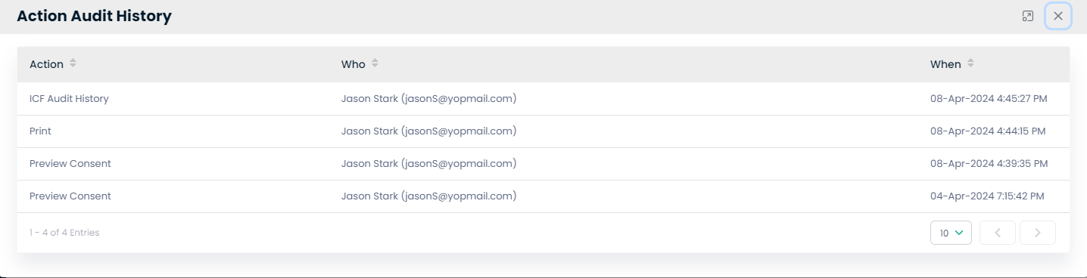

Add Task:

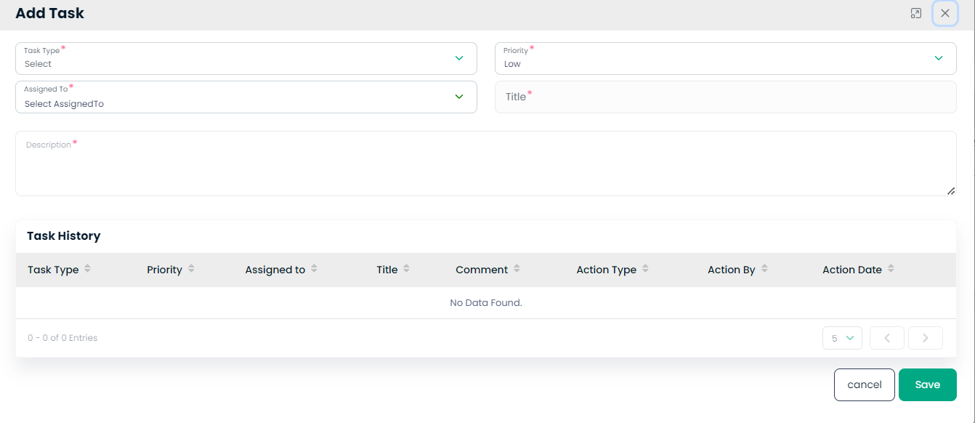

Manager

Screening Visit:  
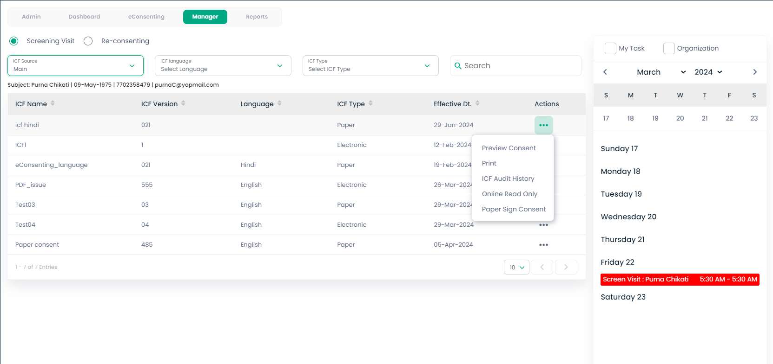

**Managing Consent Forms in a Clinical Trial Management System**

**Step 1: Navigating to eConsenting**

1. In the system dashboard, locate and click on the 'eConsenting' tab.
2. Choose the appropriate visit type, such as 'Screening Visit' or 'Re-consenting'.

**Step 2: Managing ICF Documents**

1. In the eConsenting management section, select the subject using their name or unique ID.
2. The table will display various ICF documents related to the selected subject.
3. Use the filters like ICF Source, ICF Language, and ICF Type to refine the list as per the requirement.

![Insert Screenshot Here: ICF Documents Management Screen]

**Step 3: Performing Actions on ICF Documents**

1. Next to each ICF Name, there are options to 'Preview Consent', 'Print', 'View ICF Audit History', or 'Online Read Only'.
2. Select the appropriate action to manage the document. For instance, click 'Preview Consent' to view the consent form, or 'Print' to get a physical copy.

![Insert Screenshot Here: ICF Action Buttons Screen]

**Step 4: Scheduling and Tracking Tasks**

1. On the same page, there’s a calendar view under 'My Task'.
2. You can view scheduled tasks and meetings here.
3. If there's a specific task for a consent form, such as a screen visit, it will appear on the calendar.

![Insert Screenshot Here: Task Calendar Screen]

Preview Consent:

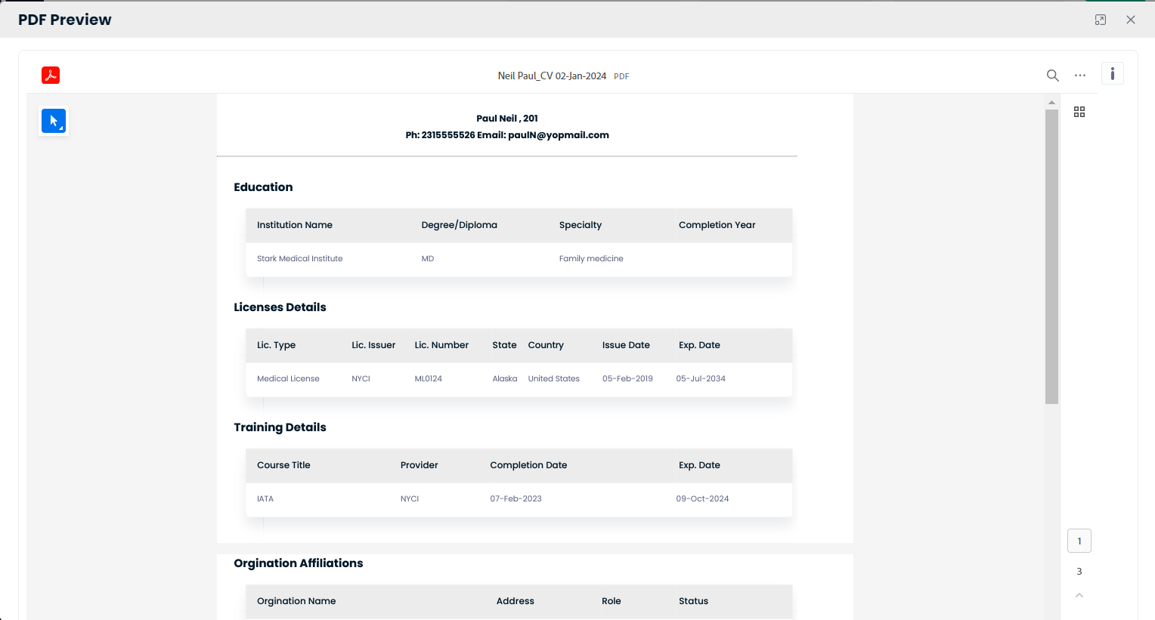

Print:  
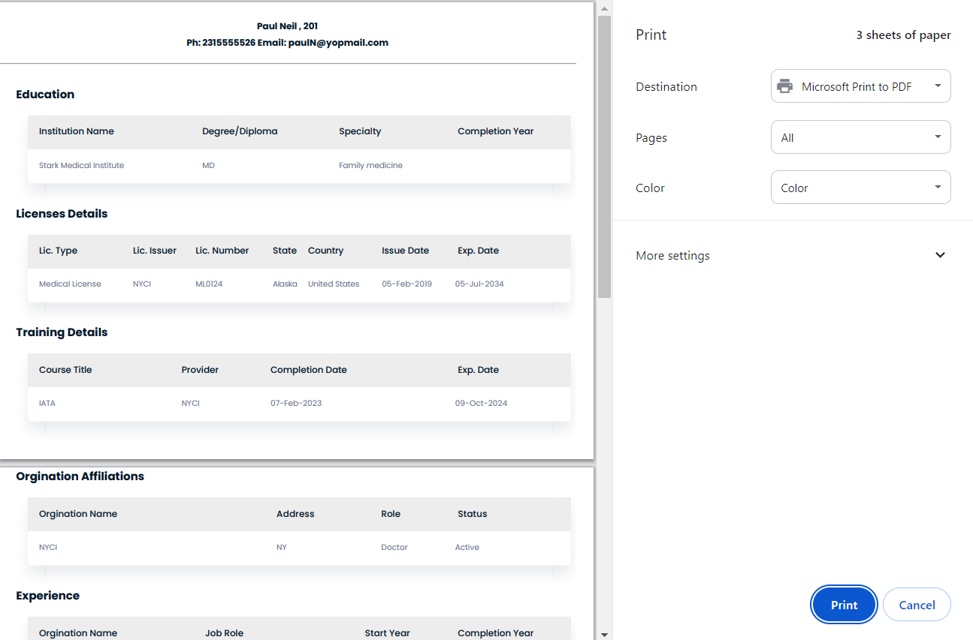

Paper Sign consent:  
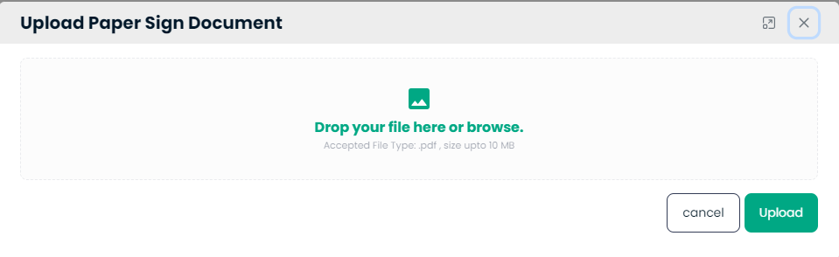

**Uploading Signed Consent Forms**

**Step 1: Accessing the Document Upload Feature**

1. From the main dashboard, navigate to the 'eConsenting' section.
2. Click on the 'Manager' tab to access document management features.

**Step 2: Uploading Paper Signed Documents**

1. Locate and click on the 'Paper Sign Consent' button next to the ICF you wish to update.
2. You will be directed to a new window titled 'Upload Paper Sign Document'.
3. Here, you can either drag and drop the scanned signed document into the box or click to browse your computer for the file.
4. Accepted file types are usually **.pdf**, with a maximum size limit.

![Insert Screenshot Here: Document Upload Interface]

**Step 3: Managing Consent Documents**

1. After uploading, the document will appear in the ICF list with its type set to 'Paper'.
2. You can perform additional actions such as 'Preview Consent', 'Print', or view the 'ICF Audit History'.

![Insert Screenshot Here: ICF Management Interface]

**Step 4: Verifying the Upload**

1. Ensure the status of the document is updated to reflect the new paper signed version.
2. Review the ICF Audit History to verify that the upload action is recorded correctly.

Manager-Re-Consenting:

**Managing Consent Forms**

**Step 1: Accessing Consent Forms**

1. From your main dashboard, click on the 'eConsenting' tab.
2. Select the 'Manager' tab to view and manage Informed Consent Forms (ICFs).

**Step 2: Reviewing ICFs**

1. Examine the list of ICFs displayed under the 'ICF Name' column.
2. Review their versions, language, and types to locate the specific document you need.

![Insert Screenshot Here: eConsenting Manager Interface]

**Step 3: Action on ICFs**

1. For each ICF, you have several actions available under the 'Actions' column.
2. You can preview the consent ('Preview Consent'), print it out ('Print'), view the history of changes made to the ICF ('ICF Audit History'), or read it online ('Online Read Only').
3. To add a paper-signed consent, click on the 'Paper Sign Consent' action.

![Insert Screenshot Here: ICF Actions Interface]

**Step 4: Uploading Signed Consent Forms**

1. After selecting 'Paper Sign Consent', you will be prompted to upload the signed document.
2. Ensure to scan the document clearly and have it ready for upload in the appropriate format (usually PDF).

**Note**: Always confirm the upload by checking that the status is updated and the action is logged in the ICF Audit History.

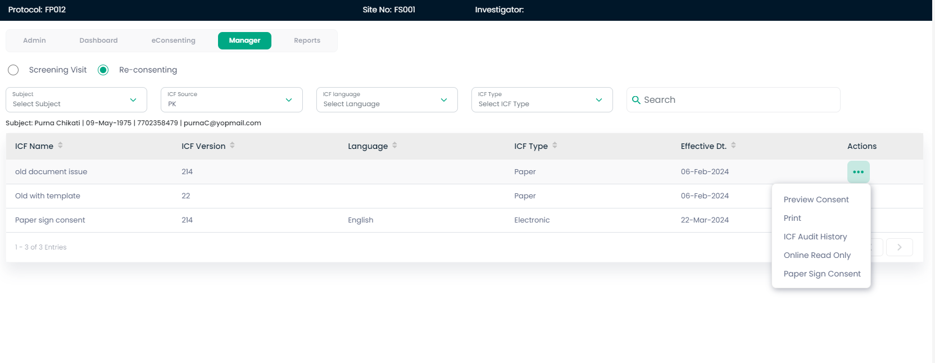

Reports:  
